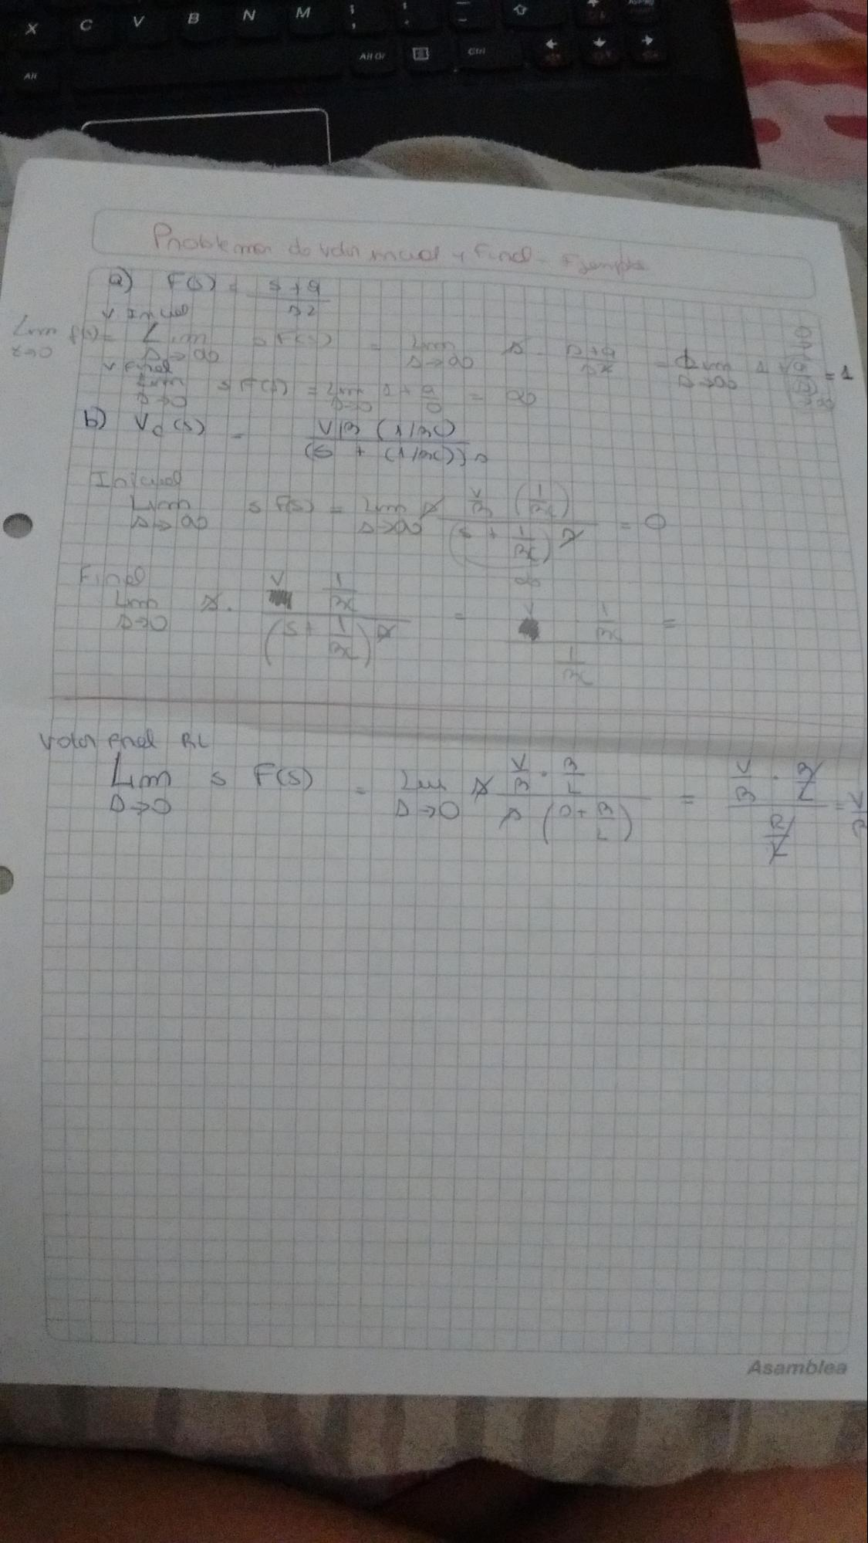

C

Aft

Toblem

do vou

col

find

VID

(5

+ CM

))

Lima Alap

1 TSS

Fin

C

vol prel BL

OCV

oto/

Asamblea